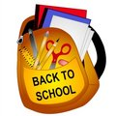**Pre-Primary Supplies 2024-25**

* **Good sized backpack**
* **Lunch bag**
* **Water bottle**
* **Change of clothes**
* **Outdoor gear (hat, splash pants, rubber boots)**
* **Indoor sneakers**
* **Wet bag for soiled clothing**

**Please label all items!**