Holland Road Elementary School

Parents/Guardians

Creating an Account
- Go to the address for your school: http://www.parentinterviews.com/holland-road
- Click the Create New Account button.
- Enter your name, email address, phone number, and choose a password.
- Click Continue.

How do I change or reset my password?
- Go to the address for your school: http://www.parentinterviews.com/holland-road
- Click the Forgot Password? link below the login form.
- Enter your email address in the field and click Continue.
- Check your email - follow the link contained in the email.
- Enter your new password into the Password and Confirm Password fields and click Continue.
- Your password has been updated - you can now log in as usual.

Scheduling Appointments
- Click Make Appointments from the main menu.
- Add a Student to your account by completing the form.
- if you have already added student(s) to your account you won't see this step
- Select the Student(s) you would like to book appointments for from the list.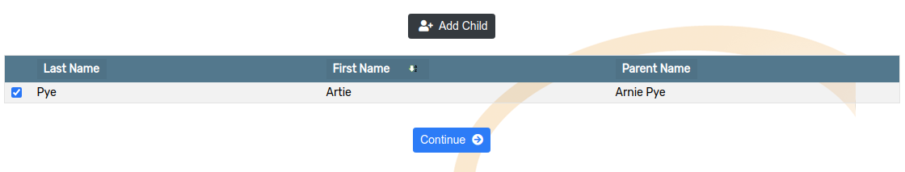
- Choose a date, or a specific timespan, from the available options.

- Choose the Teacher(s) which you would like to meet with from the available options.
- if you are scheduling appointments for more than one Student this step will be repeated 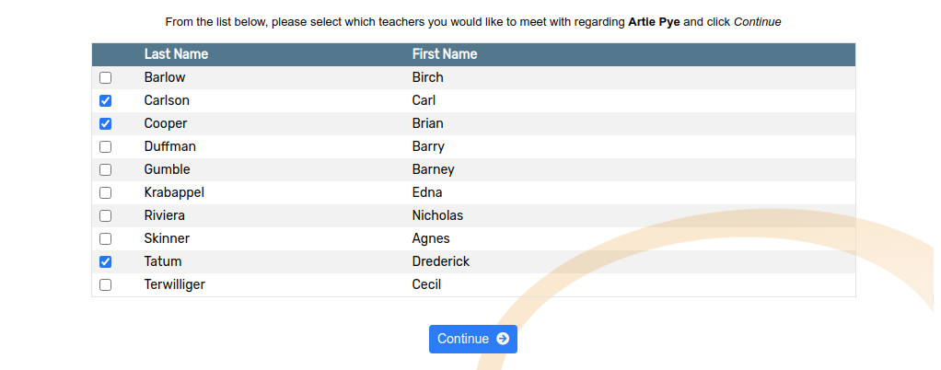
- For each Teacher, use the dropdown menus to select from the available appointment times.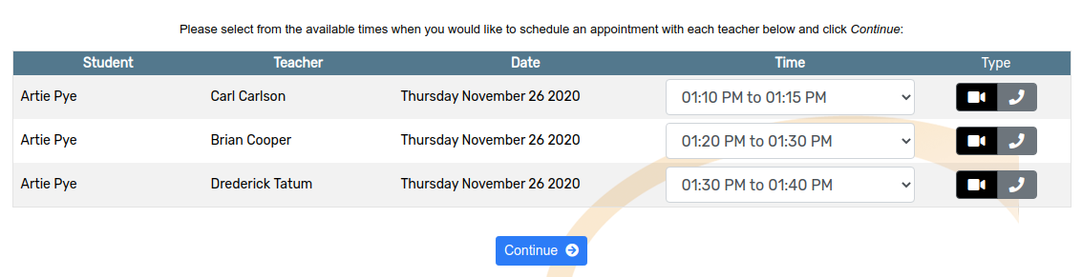
- Click Continue to reserve your appointment times.

Changing the time or date of an existing appointment
- Click My Schedule from the main menu.
- Find the appointment you would like to modify in the list of appointments.
- Click the Edit Appointment button in the right-hand column of the appointment row.
- Change the Date or Time of your appointment by using the dropdown menus to select from the available options>
- Click Continue to save your changes.

Cancelling an appointment
- Click My Schedule from the main menu.
- Find the appointment you would like to cancel in the list of appointments.
- Click the Cancel Appointment button in the right-hand column of the appointment row.
- The Appointment has been cancelled.

Adding a child to your account
- Click My Account from the main menu.
- Click My Children from the dropdown menu.
- Click Add Child.
- Complete the First Name and Last Name fields.
- Click Continue.

