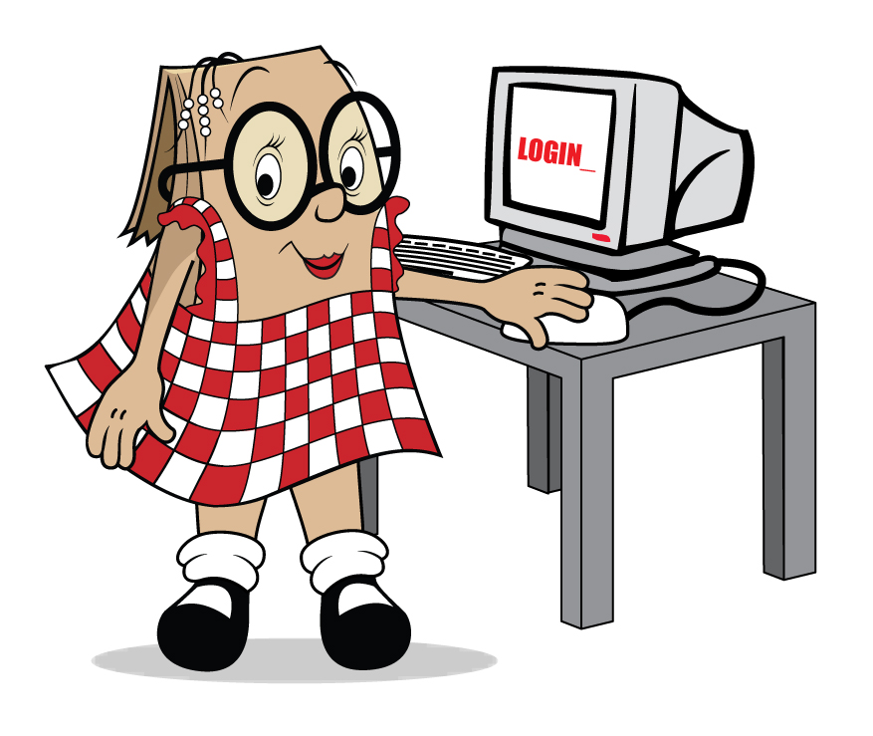

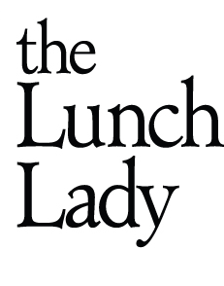


Dear Parents of Holland Road Elementary

The Lunch Lady will be coming to your school

Beginning Tuesday November 28th

We will be delivering every Tues & Thurs

The Lunch Lady is an all-Canadian success story which began in 1993 with one MOM and one lunch order for one school. Today the Lunch Lady Family delivers thousands of lunches every day to children in schools across Canada.

Every lunch:
- respects current provincial nutritional standards
- is prepared daily with care in an inspected, school safe commercial kitchen
- includes any applicable taxes and often a contribution to your school
- gives busy parents like YOU a welcome break!

CALL US FIRST with any questions about:
- Setting up Your Account
- Meals for children with Allergies
- Your Child’s Lunch Order

Things do go wrong on occasion but we are committed to making things right and we want to hear from you.

We remain at the school for the lunch break so please remind your child to look for us if they have any questions about their lunch.

If you require plastic cutlery, please select it under “FIXINGS” or send a fork and spoon from home. Many thanks if you can help us reduce the amount of plastic cutlery we deliver.

Sincerely Laurie
902-329-LADY (5239)
laurie@thelunchlady.ca


Visit www.thelunchlady.ca to learn more about our company
LIKE us on Facebook at “lunch lady group”

ORDER ONLINE – FLEXIBLE SAFE AND SECURE

To get started you will need a PASSWORD

Go to www.thelunchlady.ca and click on ORDER NOW to open the login screen.

Select “REGISTER NOW!” and fill in the required Account Holder Information and Submit.

Return to the Login screen and LOG IN

Go to “My Students” and Set up accounts for your child[ren]

You are now ready to go to “Schedule My Meals” and order.

Order as little or as often as you like. You will receive a transaction report each time you are on our site outlining any activity.

Order by Sun midnight for a Tues Delivery*

Order by Tues midnight for a Thurs Delivery*
(Call me for help if you miss the cutoff)

A few tips for using our online site

- If you know what you wish to order, “Type and Tab” your way through the order grid
- Use the scroll bar to move up and down the list of food items. We have lots of choice to look at.
- More than one child? You can Enter and Save after each child and pay once at the end
- Pay by MasterCard, Visa, Visa Debit or Interac via a secure 3rd party partner. No credit card information is stored on our site.
- To avoid the 10 minute TIME OUT and lose your order, SAVE every now and then if necessary.
- Revisit the site anytime to review your order, your order history or make changes by selecting new codes or delete lunches by clicking on the red – [minus] icon beside the lunch date.
- If your child has allergies, please call FIRST
- If your child is absent, contact us prior 8 AM BY PHONE to have the lunch credited to your account [sorry no refunds- credits only]

You can also forward any questions or concerns to
support@thelunchlady.ca

WE are so looking forward to serving your school!

